
User Reference Manual, ver. 10.03.15
Sierra Logging system
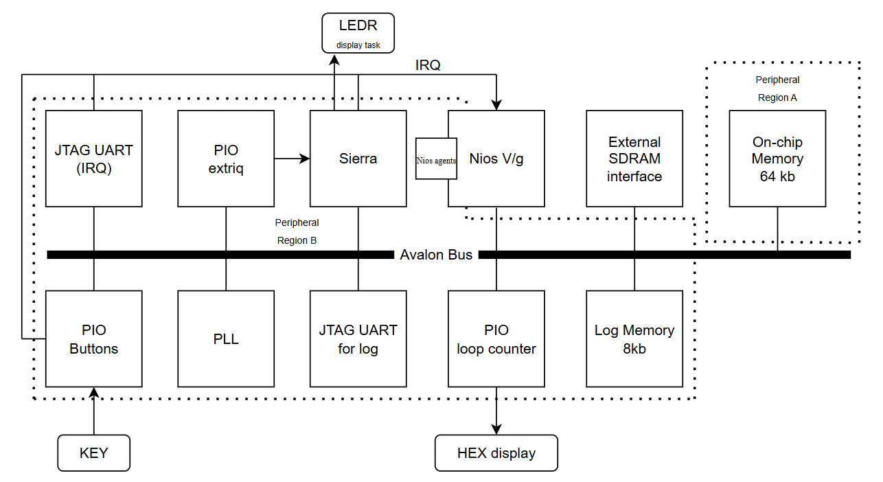

This manual covers test system for SIERRA. This hardware enables more advanced logging functionality and tests depended on extra hardware.
This manual will not cover specifics on Sierra RTL system.

© Copyright by publisher AGSTU AB.
www.agstu.com

All rights reserved. No part of this book may be reproduced, in any form or by any means, without permission in writing from the publisher.

The author and publisher of this manual make no warranty of any kind.
Contents
Introduction 7
About This Manual 7
Revision History 7
Purpose 8
Terms 8
Sierra Overview 9
Sierra HW 9
HW Scheduler 10
Setup and Initiating 12
Sierra Hardware/Software Initiation 12
Description 12
Function declaration 12
Argument 12
Return codes 12
Set and Read Time Base Register 12
Description 12
Function declaration 13
Argument 13
Return codes 13
Example 13
Low level API 14
Task Management 14
sierra_create_task 14
sierra_start_task 15
sierra_get_task_info 16
sierra_tsw_off 17
sierra_tsw_on 18
sierra_block_task 18
sierra_change_task_prio 19
sierra_delete_task 19
IRQ Management 20
sierra_await_irq 21
Time Management 21
sierra_period_time_init 23
sierra_await_next_period 23
Semaphore Management 25
sierra_take_sem 25
sierra_release_sem 26
sierra_read_sem 27
Flag Management 27
sierra_await_flag 29
sierra_set_flag 29
sierra_clear_flag 30
Sierra information calls 31
Sierra HW Version 31
Sierra SW Version 32
Logging API 34
Sierra Time Logging Register 34
ON/OFF Logging System 34
Logging functions 35
Sierra Logging Probes 36
Extended API 37
Mailbox 37
sierra_mbox_get_required_size 37
sierra_mbox_init 38
sierra_mbox_send 38
sierra_mbox_read and sierra_mbox_peak 39
Hardware interface 41
Protocol with external start of blocked task (extended Sierra) 42
Sierra SW File Structure 43

Introduction

About This Manual
This manual is describing the low-level API service calls direct to the hardware-based Sierra.
The Sierra RTK/RTOS consists of following parts (see next figure):
- Hardware based Sierra is connected to the data bus, it works as a hardware accelerator for real-time kernels/operating systems
- Software_Reference_Manual is a description of the basic RTK device drivers to Sierra HW

Revision History

Date | Description
2013-03-18 | Updated the documentation
2014-07-18 | Updated the documentation
2015-02-03 | Added task delete and some text debugging
2016-03-03 | Added “task_change_prio” and some text debugging, version 9.2
2016-04-17  v 9.3.1 | Change in the scheduler; lowest priority is 0. Same as FreeRTOS  Add Block task of other then the running. Same as FreeRTOS  Update version register
2016-05-01  V 9.4.0 | #semaphore is not bounded to #tasks  Sierra Version register updated (see Sierra HW Version)
2017-10-29  V9.4.1 | Some updates and optimizations, also a new students Sierra.
2020-04-01 | New crypted version of HW Sierra
2022-09-27  V 10.03.15 | - Added “sierra_print_versions()”,  - Added prefix sierra_ for functions,  - Updated documentation.  - Add a logging timer, count on the time ticks (32 bits). CPU Time Logging Register, working with Sierra HW version 9.5.0 and higher.  - Update SW test and add test_000_testing_time_register  - Some errors in test cases fixed  - Logging functions with probes in Sierra  - Extended with Mailbox  Change task test is not working in Sierra_HW version 9.5.0 (bug)

Purpose
The purpose of this Reference Manual is to give programmers the API to Sierra Real-Time Kernel.

Terms
API | Application Programmers Interface, The sum of all function calls available to an application programmer
Application mode | A description of a complete system with scheduler, tasks etc. some RTOS allows the programmer to specify more than one mode. I.e., an aircraft control system may have different modes for takeoff, landing, and level flight.
Context switch (task switch) | Switch from current running task to another task by saving current task status, registers etc., and restore status of the task that shall start to run.
Embedded system | A computer system that forms a component of a larger system and is expected to function without human intervention.
Exception | Software interrupts.
Interrupt service routine (ISR) | The routine that is called when an interrupt occurs.
IP | Intellectual Property, this is HW/SW components with a specific function.
Real-time system | A real-time system is one in which the correctness of the system depends not only on the logical result of computation, but also on the time at which the results are generated.
RTOS | Real time operating system, an operating system designed to be used in real time systems.
Task/Thread/Process | A task is a sequential programming performing certain functions, a real time application is usually made up of one or more sets of communicating tasks.
TCB | Task control block, a structure containing information about a task, its state, stack owned resources, the value of the processor registers etc.

Sierra Overview
Ordinary real-time operating systems are implemented in software. The Sierra are the basic functions implement in hardware, i.e., scheduling, inter process communication, interrupt management, tick handling, logging, and time management control into hardware. This makes it possible to take advantage of hardware characteristics such as parallelism and robustness that consequently decreases system overhead and decrease response time.

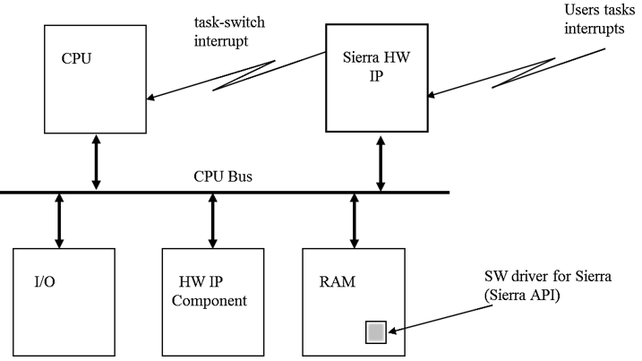
The figure shows Sierra implemented in a computer architecture. The Sierra HW IP is connected to the CPU bus, driver interface, in software (Sierra API) and an interrupt connection to the CPU. The task-switch interrupt to the CPU starts pre-emption of the running task.

Sierra HW

The Sierra HW core is partitioned into modules as shown in the figure.
Tmq = Time Manager  Rmq = Resource Manager  Irq = Interrupt Handler  TDBI = Technology Dependent Bus Interface  GBI = General Bus Interface | 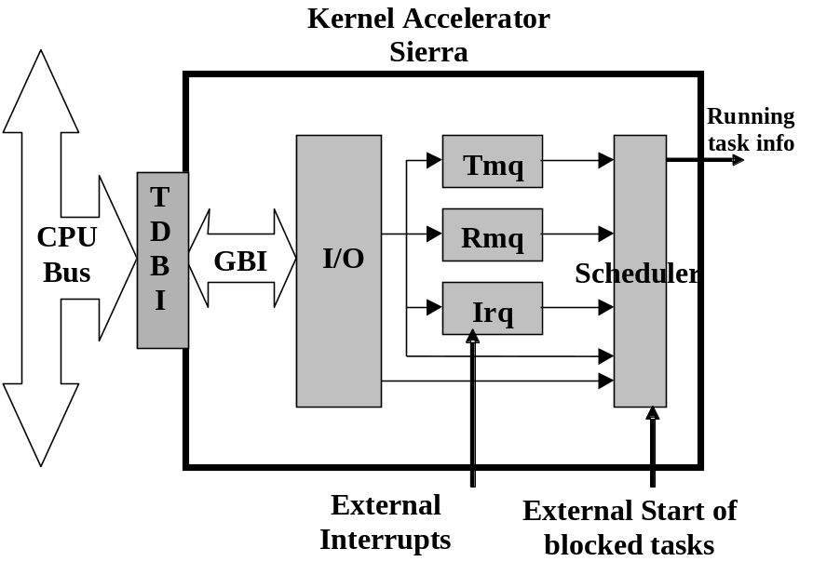
Figure 1. Overview of internal blocks in Sierra HW part
Sierra RTOS is partitioned into these functional units:
Interface
Scheduler
Semaphore and Flag Handler
Time Management Controller
Tick counter for logging
The interface to Sierra is divided into a generic bus interface (GBI) and a technology dependent bus interface (TDBI). The GBI is bus independent while the TDBI is glue to the specific bus in the system. This design of the Sierra makes it very easy to interface it towards different busses.
All communication (service calls) with the Sierra is carried out through registers. In the internal module interface, the service calls are decoded and routed out the unit that will carry out the service call. This interface synchronizes external accesses from the CPU as well as all internal work between modules in the chip.
The Sierra hardware can be configured as following:
- 4-512 tasks
- 4-512 priority levels
- 4 -1024 semaphores
- 4 -1024 flags
- 4 – 512 Timers for delay, periodic tasks
- 2 – infinite interrupts

More about the hardware in the book “Advanced HW/SW Embedded System for Designer” (Amazon)

HW Scheduler
The Scheduler unit controls all task scheduling in the Sierra. The scheduler can handle tasks at different priority levels. Tasks can also be created and deleted dynamically during runtime. When a task is created, it is initialized to a specified state (blocked or ready).
A task can exist in five different states; running, ready, blocked, waiting for IRQ or dormant. The scheduler guarantees that the task with highest priority among the ready tasks always will run.
The Sierra can support the following task states and transitions:
- Running
- Ready
- Blocked /Waiting
- Wait for interrupt
- Dormant

Setup and Initiating

Sierra Hardware/Software Initiation

Description
Initiate the TCB in soft/hardware and resets the Sierra hardware. After initiation the task switch is off.

Function declaration
void sierra_initiation_HW_and_SW(void)

Argument
Nothing

Return codes
N/A

Set and Read Time Base Register

Description
Sets or read the internal clock-tick timebase for the Sierra. This register is used to set-up the generating of Sierra internal clock tick period for all timing queues in Sierra.
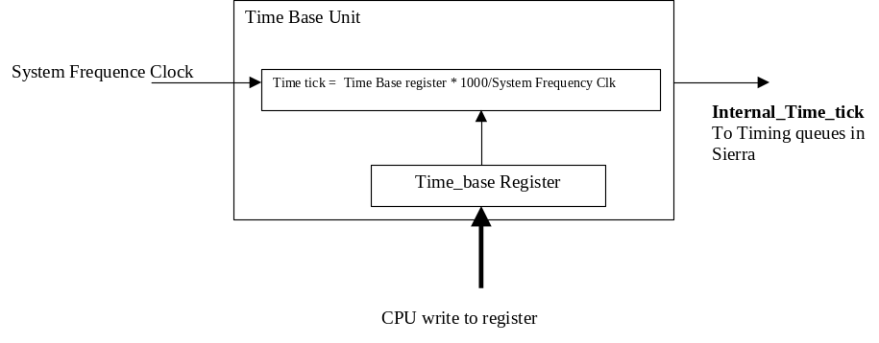
Figure 2. Time Base Unit

Sierra Time Base register value = Time tick * system Frequency/1000

Function declaration
set timebase  read timebase | void sierra_set_timebase (unsigned int hex)  unsigned int sierra_time_base_reg(void)

Argument
set timebase  read timebase | See Sierra specification for number of bits:/13 bits; hex: range 0-8191, please check the version of hardware. unsigned int  N/A

Return codes
set timebase  read timebase | N/A  unsigned int

Example
void t1(void)
{
sierra_set_timebase(50); /* Set Sierra internal
clock-tick to 1ms
when the HW kernel
runs at 50 MHz
system clock*/
}

Low level API

Task Management
This section describes the task handling services provided by the scheduler in the Sierra. The difference between Sierra and other RTOS kernels is that all scheduling is performed by a hardware piece instead of software. The only software is the driver that communicates with the hardware kernel. The following task management functions are implemented in the Sierra hardware kernel:
Dynamic creation of tasks (sierra_create_task)
Starting of tasks (sierra_block_task)
Yield (sierra_yield_task)
Get task status (sierra_get_task_info)
Task switch off and on (sierra_tsw_on and sierra_tsw_off)
Change task priority

Ready que is organized in two ways (scheduling algorithm):
- Priority driven (lowest priority is 0)
- Same priority is sorted in ID number order, from low to high.
- Preemption

Idle task must be created with task ID 0 and lowest priority (0).

sierra_create_task

Description
Creates a task with a unique task id. The task will be initialized to a state (blocked or ready) as specified in the argument. It is possible to create new tasks dynamically during system execution. Idle task must be created and have task ID 0 and lowest priority (0).

Function declaration
void sierra_create_task (int taskID,
int priority,
int taskstate,
void (*taskptr)(void),
void *stackptr,
int stacksz);

Argument
task ID | Specifies the ID of the task (range depend on the version of Sierra). An idle task must be created, and this task shall have task ID 0.
priority | Specifies the priority of the task. The range is dependent on the version), where 0 is the highest-priority level. Highest ID number is reserved only for the idle task.
taskstate | 0 = task is initialized to the blocked state (BLOCKED_TASK_STATE)  1 = task is initialized to the ready state (READY_TASK_STATE)
taskptr | Pointer to code start for the task
stackptr | Pointer to task stack
stacksz | Size of the stack

Return codes
N/A

Example
#define IDEAL 0
#define READY 1
#define PRIO1 0
#define STACK1_SZ 200
#define T1 1
#define READY 1
#define PRIO1 1
#define STACK1_SZ 200

char stack1[STACK1_SZ];

void t1(void)
{
task code;
}

void function(void)
{
sierra_create_task(T1, PRIO1, READY, t1, stack1, STACK1_SZ);
}

sierra_start_task

Description
Starts a task that is currently placed in blocked state (un-block the task). Starting a task means that the task is sent into the ready state (see section 2.4., Scheduler) and does not mean that the task starts to execute immediately. The task will be moved from blocked state to ready state.

Function declaration
void sierra_start_task (int taskId)

Argument
task ID Specifies the ID of the task (range depend on the version of Sierra).

Return codes
N/A

Example
#define T2 2

void t1(void)
{
sierra_start_task(T2); /* t1 starts T2 */

while(1)
{
/* Insert code*/
}
}

sierra_get_task_info

Description
Get status information about a specified task.

Function declaration
task_info_t sierra_get_task_info (int taskid)

Argument
task ID Specifies the ID of the task (range depend on the version of Sierra)

Return codes
task_info_t | state_info (2 bits):  0=Running  1=Blocked  2=Ready  3=Dormant  priority (3 bits, depend on the version of Sierra),  7 is the lowest priority level and 0 is the highest.

Example

task_info_t info;

printf("Task1\n");
info = task_getinfo(Task1);
printf(" info.state_info = %d\n", info.state_info);
printf(" info.priority = %d\n", info.priority);

Return:
Task 1
info.state_info = 2
info.priority = 1

Special print function (sierra_info.c)
void sierra_task_info(void)

Return:
Idle
info.state_info = 2
info.priority = 0
Task 1
info.state_info = 2
info.priority = 1
Task 2
info.state_info = 2
info.priority = 2
Task 3
info.state_info = 2
info.priority = 3

sierra_tsw_off

Description
Disables task-switch interrupts in the system. This is useful when a critical section is entered. Anyhow, this call should be used with restrictions in a real time system as it has effects on how/when tasks can start to run. If this call is used, try to have the task-switch interrupt off as short time as possible.

Function declaration
void sierra_tsw_off (void)

Argument
N/A

Return codes
N/A

Example
void t1(void)
{

while(1)
{
sierra_tsw_off(); /* Entering critical
section,turn off
task-switch interrupts */
}

}

sierra_tsw_on

Description
Enables task-switch interrupt.

Function declaration
void sierra_tsw_on(void)

Argument
N/A

Return codes
N/A

Example
void t1(void)
{

while(1)
{
tsw_on(); /* Leaving critical section - Turn on
task-switch interrupts */
}
}

sierra_block_task

Description
Blocks the currently running task. The task will be moved from running state into blocked state. It is not allowed to block idle task.

Function declaration
void sierra_block_task (int taskId)

Argument
task ID Specifies the ID of the task (range depend on the version of Sierra).

Return codes
N/A

Example
#define T2 2

void t1(void)
{
int i=0;
while(1)
{
i++;
if(i==10) /* Block t2 when I == 10 */
{
task_block(T2);i = 0;
}
}
}

sierra_change_task_prio

Description
This call changes a task's priority to a specified priority. It is not allowed to change idle task priority.

Function declaration
void sierra_change_task_prio (int taskID,
int priority);

Argument
task ID | Specifies the ID of the task (range depend on the version of Sierra).
priority | Specifies the priority of the task. The range is dependent on the version), where 0 is the highest-priority level. Highest ID number is reserved for the idle task.

Return codes
N/A

Example
#define T2 2
#prio_5 5

void t1(void)
{

sierra_change_task_prio(T2,prio_5);
/* Task T2 gets priority 5 */

while(1)
{
/* Insert code here */
}
}

sierra_delete_task

Description
Delete the running task, preformed from current executing tasks code. The task will be moved from the system and the task ID number will be free for use again. To restore a deleted task the removed task must be created again. It is not allowed to perform this call from the idle task.

Function declaration
void sierra_delete_task(void)

Argument
N/A

Return codes
N/A

Example
void t1(void)
{
int i=0;
while(1)
{
i++;
if(i==10)
{
task_delete();
i = 0;
}
/* Removed t1 from the system when i==10 */
}
}

IRQ Management

This section describes the functionality of the Interrupt Manager. The interrupts are associated with an interrupt task, which is scheduled as an ordinary task in the system. External interrupt is connected to Sierras external IRQ pins. Each IRQ input is level sensitivity and active-high.

The following functions is implemented in hardware:
- Wait for interrupt

If several external interrupts occur simultaneously, the task associated with highest interrupt pins will be the first one sent to the ready queue.

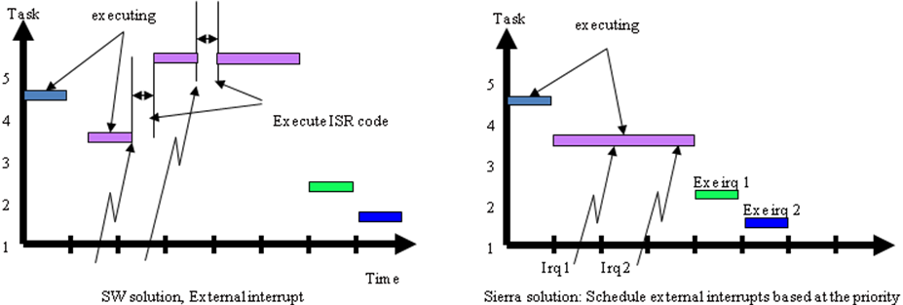
Figure 3. SW RTK and HW based Sierra solution, two low priority IRQ.

sierra_await_irq

Description
This call used when an interrupt service task is ready to process to wait for an external interrupt. As a result of this call, the interrupt service task (running task) will be moved to the ‘Wait for interrupt’ state.
The ID of task that the CPU should context switch too is in the return data.

Function declaration
void sierra_await_irq(int IRQ_number);

Argument
IRQ number Specifies the interrupt level. The range of the interrupt level depends on the version of the Sierra.

Return codes
N/A

Example
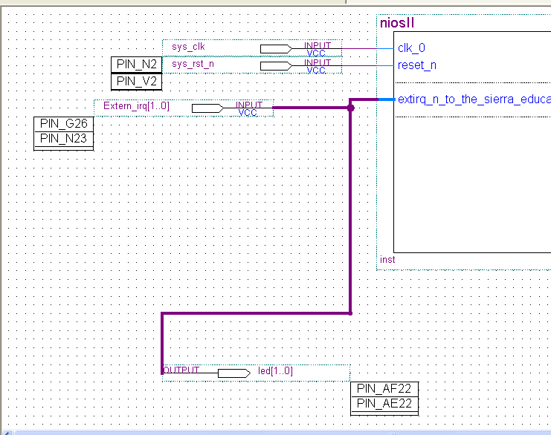
Figure 4. Setup example for two external IRQ

void irq_task_code(void)
{
int i=0;
printf("IRQ Task starts\n ");

while(1)
{
sierra_await_irq(1); //Wait for external IRQ 1
printf("IRQ 1 start\n");
for(i=0; i<500000; i++); //virtual load
sierra_await_irq(0); //Wait for external IRQ 0
printf("IRQ 0 start\n");
for(i=0; i<500000; i++); //virtual load
}
}

Time Management
This section describes the functionality of the time management controller. The following functions are implemented:
sierra_delay_task
sierra_period_time_init
sierra_await_next_period

Description
Blocks the calling task specified number of ticks. The task will be placed in the blocked state until the timer expires or an undelay call is performed on the task.
When the timer expires, or if the undelay call is performed, the task is placed in the ready state.

Function declaration
void sierra_delay_task (int delay_time)

Argument
delay_time | Specifies the number of ticks to delay the task.  Max value depends on the version of Sierra.

Return codes
N/A

Example
void t1(void)
{
while(1)
{
sierra_delay_task(10); /* t1 is blocked
for 10 ticks *
}
}

sierra_period_time_init

Description
Initialize the period time for the calling task. This function must be performed before the use of the function sierra_await_next_period(). See the version of Sierra for the max value. Possible to use deadline control, to detect starvation.

Function declaration
void sierra_period_time_init (int period_time)

Argument
Period_time | Specifies the period time, in number of ticks, for calling task.

Return codes
deadline_control
N/A

Example
void t1(void)
{
sierra_period_time_init(100); /* Initialize period
time for t1 to
100 ticks */
while(1)
{
/* Insert code here */
}
}

sierra_await_next_period

Description
Suspends a periodic task until the start of next period time. If you miss a periodic start, Sierra will skip this period, not to disturb the other tasks, the miss to the periodic task will be reported. The deadline is the same as the period time.
To use deadline control cost no extra execution or response time to manage.

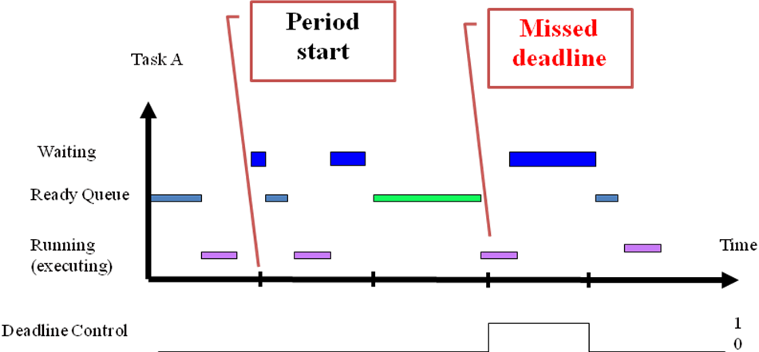
Figure 5. Periodic start with deadline control.

Function declaration
void sierra_await_next_period (void)
task_periodic_start_union sierra_await_next_period (void)

Argument
deadline_control:
0: Ok, deadline not missed.
1: missed at least one deadline.

Return codes
N/A

Example
// Without deadline control
void t1(void)
{
init_period_time(50);

while(1)
{
sierra_await_next_period();
}
}
// With deadline control
task_periodic_start_union test;

while(1)
{
test = sierra_await_next_period();

if (test.periodic_start_integer & 0x1)
printf("deadline miss, timer task");
}

Semaphore Management
This section describes the functionality of the semaphore management. The semaphores are used in the system to protect shared resources and for synchronization of different tasks.
There are 8 binary semaphores available in the Sierra. A semaphore can have a queue of waiting tasks of the same length as the number of tasks in the system. This means that a semaphore can be taken by one task and up to 8 other tasks can be waiting for it. The queue is arranged by task ID numbers. Task with highest ID number in the queue will run when the semaphore becomes available.
The following semaphore handling functions are supported:
sierra_take_sem
sierra_release_sem
sierra_read_sem

sierra_take_sem

Description
Makes a task pending (waiting) for a semaphore. If the semaphore is free, the task will continue to execute immediately. If the semaphore is allocated by another task, the calling task will be suspended and put in a semaphore waiting queue, until the semaphore becomes free.
Note: The queue is arranged in task ID numbers and task with highest ID number in the queue will get the semaphore when it becomes available.

Function declaration
void sierra_take_sem (int semID)

Argument
semID | Semaphore number (0-15)

Return codes
N/A

Example

#define SEM1 1

void t1(void)
{

while(1)
{
sem_take(SEM1); /* Pend on semaphore 1 */
}
}

sierra_release_sem

Description
Releases a specified semaphore. If there are one or more tasks waiting for the semaphore, the first task in the semaphore waiting queue will get the semaphore and will be moved to ready state.

Function declaration
void sierra_release_sem (int semID)

Argument
semID | Semaphore number

Return codes
N/A

Example
#define SEM1 1

void t1(void)
{

while(1)
{
sem_release(SEM1); /* Release semaphore 1 */
}

}

sierra_read_sem

Description
Read a task’s semaphore status.

Function declaration
Sem_info_t sierra_read_sem (int taskID)

Argument
taskID | Specifies the taskID to read status of.

Return codes
Sem_info_t
status 0 = The task is not waiting for a semaphore (ignore semID)
1 = The task is waiting for a semaphore (Read semID)
semID Semaphore number if specified task is waiting for a
semaphore.

Example
#define SEM3 3

void t1(void)
{
sem_info_t sem;
int semID, status;

while(1)
{
sem = sem_read(T2); /* Read semaphore status of
task T2 */

/* The different member variables in the
returned data-structure: */
status = sem.status;
semID = sem.semID;

}
}

Flag Management
The Sierra has support for flags for efficient synchronizing of events. The entire synchronizing algorithm is handled by the hardware kernel. This makes handling of flags very efficient since no valuable CPU time is spent on synchronization.
Flags are very efficient in cases where you, for example, have one or several events handled by some input tasks and there exist an output task triggered by one or several tasks - see figure 8 below.
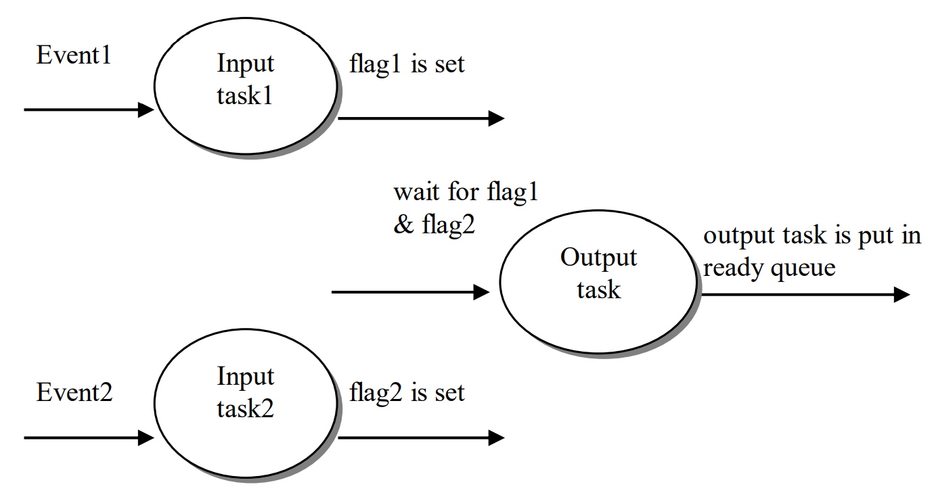
Figure 6. Flag example.
The semantics for the figure is; the output task makes a system call where it will need a combination of flags set to be able to continue to run. If this combination is not true at the time when the call is performed, the task will be suspended until the combination becomes true. Task1 runs and sets flag1. At this point the output task will not be made ready, as it asks for an AND operation between flag1 and flag2. When task2 has set flag2, the output task will be made ready. The output task is scheduled and will start to run when it has the highest priority in the ready queue.
If the Sierra is configured to support 4 flag bits, the flag bits can be used in 2⁴-1 (=15) different combinations.
The following flag handling functions are supported:
sierra_await_flag
sierra_set_flag
sierra_clear_flag

sierra_await_flag

Description
This call makes a task wait for one or more flags to be set. If the flag(s) are already set, the task will continue to run, if not it will be suspended until the combination is set.

Function declaration
void sierra_await_flag (int flag_mask)

Argument
flag_mask | The four lowest bits are used, values between 1-15 are valid. 0 is not a valid flag value.

Return codes
N/A

Example
#define FLAG_MASK 5 /* Flag1 AND Flag3 -> 0101 */

void t1(void)
{

while(1)
{
Sierra_await_flag(FLAG_MASK); /* Wait for Flag1
and Flag3 to be
set */
}
}

sierra_set_flag

Description
This call sets one or more flags. If there are any task(s) waiting for the specific combination of flags that are set during the call, they will be made ready and start to run when they have the highest priority in the ready queue.
If a task is waiting for a combination of flags and the call only sets one or few of the flags, the waiting task will not be activated before all flags are set.

Function declaration
void sierra_set_flag (int flag_mask)

Argument
flag_mask | The four lowest bits are used, values between 1-15 are valid. 0 is not a valid flag value.

Return codes
N/A

Example
#define FLAG_MASK 7 /* Flag1 AND Flag2 AND
Flag3 -> 0111 */
void t1(void)
{

while(1)
{
sierra_set_flag(FLAG_MASK); /* Set Flag1, Flag2
and Flag3 */
}
}

sierra_clear_flag

Description
This call clears one or more flags. When a flag has been set, it needs to be cleared after a waiting task has taken care of the event that was waiting for the flag. If there is more than one task using the flag, it is important to know which one(s) of these tasks that will be permitted to do this call.
Example; there are two tasks waiting for a common flag, but one of the tasks is also waiting for another flag. When this flag is set, the task that only waits for this flag is made ready and will start to run when it has the highest priority in the ready queue. However, if the other task still is waiting for the other flag when this first task has done its job, this first task should not clear the flag as the other task still is depending on this flag. In this specific scenario it is the task that is waiting for both flags that should clear the flag.

Function declaration
void sierra_clear_flag (int flag_mask)

Argument
flag_mask | The four lowest bits are used, values between 1-15 are valid. 0 is not a valid flag value.

Return codes
N/A

Example
#define FLAG_MASK 7 /* Flag1 AND Flag2 AND
Flag3 -> 0111 */
void t1(void)
{

while(1)
{
sierra_clear_flag(FLAG_MASK); /* Clear Flag1,
Flag2 and
Flag3 */
}
}

Sierra information calls

Sierra HW Version

Description
Sierra Version number can be retrieved from Sierra Hardware if you call sierra_HW_version function.
- MAJOR version when you make incompatible changes,
- MINOR version when you add functionality in a backwards-compatible manner
- PATCH version when you make backwards-compatible bug fixes
- Number of tasks

Table 1: Sierra version register (binary)
31-28 | 27-24 | 23 - 20 | 19 - 16 | 15-8 | 7 – 0
MAJOR_version | MINOR_version | PATCH_version | X | Number of semaphores | Number of tasks

Function declaration
version_register_union sierra_HW_version(void)

Argument
N/A

Return codes
version_register_union | number_of_tasks (8 bits)  number_of_semaphores (8 bits)  N\A (4 bits)  PATCH_version (4 bits)  MINOR_version (4 bits)  MAJOR_version (4 bits)

Example
#include "altera_avalon_sierra_ker.h"

void sierra_hw_version_print(void)
{
version_register_union test = sierra_HW_version();
printf("Sierra HW Major Version = %d\n", test.version_register.MAJOR_version);
void sierra_hw_versions(void)
}

Return:
Sierra HW Major Version = 9

Example
Void Printf_sierra_HW_version(void)

Return:
Version = 9.5.0
Number of task bits = 3 – 8 tasks
Number of semaphore’s bits = 3 – 8 semaphores

Sierra SW Version

Description
Sierra Version number from Sierra software can be retrieved if you call sierra_SW_driver_version() function.

Function declaration
sw_version_union sierra_SW_driver_version(void)

Argument
N/A

Return codes
sw_version _union | PATCH_version (10 bits)  MINOR_version (10 bits)  MAJOR_version (12 bits)

Example
#include "altera_avalon_sierra_ker.h"

void sierra_sw_version_print(void)
{
sw_version_union info = sierra_SW_driver_version();

printf(" Sierra SW Major Version = %d\n", test.version_register.MAJOR_version);
}

Return:
Sierra SW Major Version = 10.03.15

Print Sierra Versions

Description
To print Sierra version numbers for hardware and software you can call sierra_print_versions() function. The version numbers are divided into three sections.
- MAJOR version when you make incompatible changes,
- MINOR version when you add functionality in a backwards-compatible manner
- PATCH version when you make backwards-compatible bug fixes

Function declaration
void sierra_print_versions(void)
Argument
N/A
Return codes
N/A

Example
#include "altera_avalon_sierra_ker.h"

void sierra_versions_print(void)
{
sierra_print_versions();
}

Return:
Sierra HW version 9.4.2
Sierra SW version 10.3.15

Logging API
Logging macros for three verbosity level. The levels implemented are SIERRA_LOG_INFO, SIERRA_LOG_WARN and SIERRA_LOG_ERROR.
The system would save messages from different Sierra functions and then print the results using a logging subsystem. The info level would log events during normal execution of a program and provide the user with descriptive data of how the system operated. The warning level would log incidents and abnormal events prior to execution and during runtime. The error level would address more serious concerns, for example, if the system encounters a problem from which it cannot recover.

Sierra Time Logging Register
The time register was built as a part of the Sierra hardware, and that count Sierra ticks directly from the Sierra kernel, without any external interference. The register is defined as a vector (31 DOWNTO 0), and it counts the internal time ticks (0 - 268 435 454 (dec)). After it has come to the maximum it starts from 0 again.
The function sierra_get_current_time(void) return the value from the time logging register.
Table 2: An overview of the time logging register
Description | Utilization
#define M_RD_TIME_LOGGING_REGISTER IORD_32DIRECT(SIERRA_RTOS_BASE,0x70); | Macro for reading data from hardware logging register
uint32_t sierra_get_current_time(void) | Function for returning a value from the register

ON/OFF Logging System
SIERRA_LOGGING, was created to regulate the system from being on or off. In sierra_logging.h the user can turn on and off the logging system by updating its defined value:
0 – logging is disabled
1 – logging is enabled
2 – logging is enabled with timestamps

Logging functions
The logging subsystem incorporates four different logging functions, one for each verbosity level and one for notifying the user about the current status of the logging interface. The functions print the results (info, warning or error) from Sierra functions using variadic macros.

Table 3: Logging functions from subsystem
Declaration | Usage
void sierra_print_logging_status(void) | Prints current logging status. If the macro SIERRA_LOGGING is defined then a message will be printed saying logging is active. If not defined, then the message will say the logging interface is not active.
void sierra_log_info(const char* szMsg) | The function prints informative messages and presents data from Sierra functions during normal execution of a library. If conditions are met, the function will also print the time.
void sierra_log_warn(const char* szMsg) | The function prints warning messages and presents metadata from Sierra functions that encounter abnormal activity. If conditions are met, the function will also print the time.
void sierra_log_error(const char* szMsg) | The function prints error messages and presents metadata from functions that have encountered an erroneous event. If conditions are met, the function will also print the time.

Sierra Logging Probes
Logging probes were implemented to retrieve data from Sierra functions, and these would be triggered if certain conditions were met during execution. The probes would have messages written to the logging macros before being sent to the subsystem. Next figure shows an example of logging data from Sierra.

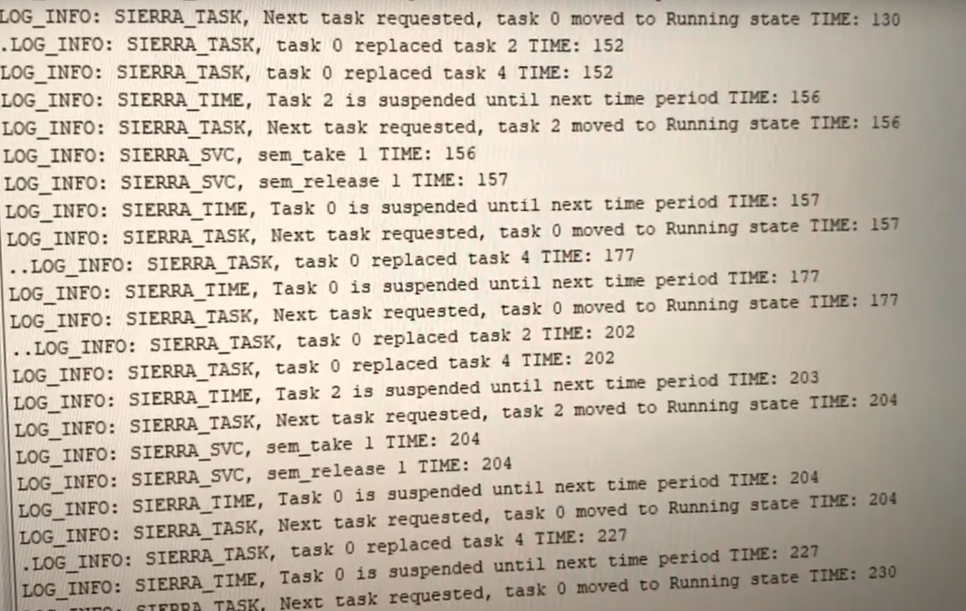
Figure 7; Example of logging data from Sierra (more information; https://www.youtube.com/watch?v=zb9rq_glQNI)

Extended API

Mailbox
This section describes the functionality of the Mailbox. The Mailbox is used for sharing data between tasks/processes in safe manner that won’t cause deadlocks or race conditions.
Mailbox is flexible to fit user needs but there are some limitations, such as 65 536 message per Mailbox with size limit of 65 536 bytes per message. Following Mailbox is implemented:
- sierra_mbox_get_required_size
- sierra_mbox_init
- sierra_mbox_send
- sierra_mbox_read
- sierra_mbox_peak

sierra_mbox_get_required_size

Description
Calculate size for char array that will be used for Mailbox.

Function declaration
extern uint32_t sierra_mbox_get_required_size(const uint16_t amount_of_messages, const uint16_t largest_message_data)

Argument
max_messages, Maximum messages.
largest_size, Largest message data.

Returns
uint32_t, that represents required size for mailbox based on inputs.

Notes/Warnings
Nothing.

sierra_mbox_init

Description
Initiates Mailbox to initial state based on passed values.

Function declaration
extern void sierra_mbox_init(sierra_mbox_queue_t* mbox, char* mem_pool, uint16_t max_messages, uint16_t largest_size)

Argument
mbox Mailbox to initialize.
mem_pool char array that will be used to store header and message/data.
max_messages how many messages can mem_pool hold.
largest_size how large will message/data be.

Returns
Nothing

Notes/Warnings
Make sure that mem_pool (aka char array) will be able to hold all the messages, the example code will show how to get accurate size for mem_pool.

Example
#include <sierra_extension/sierra_mbox.h>
. . .
// create global Mailbox that is accessible for tasks.
sierra_mbox_queue_t mbox;
. . .
void main()
{
// calculate total size needed for memory pool
uint16_t amount_of_message = 3; // amount of message that Mailbox can save.
uint16_t largest_message_data = 4; // the maximum size of the message can be saved.
// create memory pool for Mailbox
char memmory_pool[sierra_mbox_get_required_size(amount_of_message, largest_message_data)];
sierra_mbox_init(mbox, memmory_pool, amount_of_message, largest_message_data);
}

sierra_mbox_send

Description
Copies header content byte by byte to Mailbox, same with headers data that it is pointing to.

Function declaration
extern sierra_mbox_res_e sierra_mbox_send(sierra_mbox_queue_t* mbox, const sierra_mbox_header_t* header)

Argument
mbox Which Mailbox to send.
header What to save.

Returns
Returns one of the possible responses from sierra_mbox_res_e, if everything went well response will be MBOX_OK otherwise different response.

Notes/Warnings
Headers data can point to anything, it can point to struct and it will be saved to Mailbox if there is enough space in Mailbox.

Example
#include <sierra_extension/sierra_mbox.h>
...
// create global Mailbox that is accessible for tasks.
sierra_mbox_queue_t mbox;
...
void task_send()
{
...
sierra_mbox_header_t header;
header.id = 1;
...
char msg[18] = "My lucky number is";
int lucky_num = 7;
...
while(1)
{
...
header.type = MBOX_CHAR_ARR;
header.size = sizeof(msg);
sierra_mbox_send(&mbox, &header);
...
header.type = MBOX_INTEGER;
header.size = sizeof(lucky_num);
sierra_mbox_send (&mbox, &header);
}
}

sierra_mbox_read and sierra_mbox_peak

Description
Copies stored header and data that is in Mailbox to users/passed header and headers data.
Read removes the header and headers data after reading, Peak just reads the headers and headers data without removing from Mailbox.

Function declaration
extern sierra_mbox_res_e sierra_mbox_read(sierra_mbox_queue_t* mbox, const sierra_mbox_header_t* header) or extern sierra_mbox_res_e sierra_mbox_peak(sierra_mbox_queue_t* mbox, const sierra_mbox_header_t* header)

Argument
mbox Which Mailbox to read or peak.
header where to save header and headers data.

Returns
Returns one of the possible responses from sierra_mbox_res_e, if everything went well response will be MBOX_OK otherwise different response.

Notes/Warnings
Headers data needs to point user defined char array with enough space for message/data.

Example
#include <sierra_extension/sierra_mbox.h>
...
// create global Mailbox that is accessible for tasks.
sierra_mbox_queue_t mbox;
...
void task_read()
{
...
sierra_mbox_res_e res;
...
char buffer[50];
sierra_mbox_header_t header;
header.data = buffer;
...
while(1)
{
...
res = sierra_mbox_read(&mbox, &header);
if (res != MBOX_OK)
{
printf(“something went wrong\n”);
continue;
}
...
if (header.type == MBOX_INTEGER)
printf(“%d\n”, *(int*)header.data);
if (header.type == MBOX_CHAR_ARR)
{
for(int i = 0; I < header.size; i++)
printf(“%c”, *((char*)header.data + i));
}
}
}

Hardware interface

Sierra is a component with bus interface, running task ID information, external interrupt and external start of blocked tasks.
Bus interface (TDBI) can be wrapped to the most busses on the market.
Running task ID info can be used to monitor the running task or logged of another hardware units for different types of analyses.
External interrupt is direct connected to a task and the task will be scheduled before it can be running on the CPU
External start of blocked task is an advanced function to communicate with hardware units connected to SW tasks.

Figure 8. Block schematic.
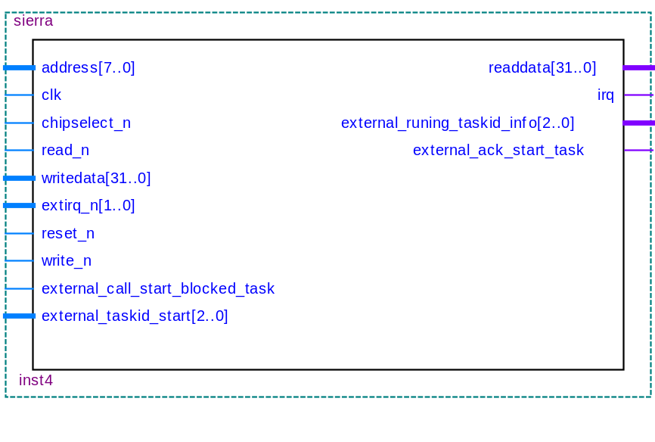
Figure 9: Sierra pin Interfaces

Table 4 Sierra Pin out
Pin name | Direction | Description
clk | Input, Sys | System clock
reset_n | Input, Sys | HW reset
cs_n | Input, Bus | Chip select
write_n | Input, Bus | Read / Write
addr(7:0) | Input, Bus | Address bus
din(31:0) | Input, Bus | Data bus in
dout(31:0) | Output, Bus | Data bus out
irq_n | Output, CPU | Task switch interrupt
extirq_n(1:0) | Input, User | External interrupts
External_runing_taskid_info[2..0] | Output, User | Updating Running task ID (binary)
external_call_start_blocked_task (extended Sierra) | Input, User | Start of Blocked Tasks, Not used = ‘0’.
external_ack_start_task  (extended Sierra) | Output, User | Start of Blocked Tasks
external_taskid_start[2..0]  (extended Sierra) | Input, User | Start of Blocked Tasks

Protocol with external start of blocked task (extended Sierra)

Start of blocked task is done with following protocol:

- Set “external_taskid_start” that should be started (it have to be in block state, block_task()) and write ‘1’ to “external_call_start_blocked_task”
- Wait for “external_ack_task_start” to be ‘1’
- Write ‘0’ to “external_call_start_blocked_task”
- Wait for “external_ack_task_start” to be ‘0’

Sierra SW File Structure

The Sierra low level API SW consists of the following files:

 Sierra_RTOS (inte uppdaterad)
 HAL
 inc
altera_avalon_sierra_io.h
altera_avalon_sierra_ker.h
altera_avalon_sierra_name.h
altera_avalon_sierra_regs.h
altera_avalon_sierra_tcb.h
altera_avalon_sierra_tcb_offset.h
sierra_logging.h

 src
csw.S (context swtich routine)
sierra.c (basic service calls)
sierra_sem.c (Semafres and flags service calls)
sierra_taskc (Task service calls)
sierra_time.c (Time service calls)
sierra_info.c (Extra logging/info service calls)
sierra_logging (logging functions)
alt_exception_enty.S (NiosII exception handling)
alt_exception_trap.S (NiosII trap handling)
component.mk (makefile)

